Income Classification with Logistic Regression
Short name: Income_LogReg | L1-logistic (C=0.05, liblinear) on age, capital-gain/loss, hours, sex, race, education.

Problem Statement
The UCI Adult extract (32,561 census records from 1994) records whether a person earned more than $50,000. The task is to build an interpretable logistic regression that predicts that binary label from a small socio-economic feature set, diagnose class imbalance and scaling, and evaluate with a confusion matrix plus ROC/AUC — not accuracy alone.

Solution Strategy
- Clean: assign official column names; strip whitespace on categoricals; drop the starter-list duplicate of hours-per-week (sklearn ≥1.8 rejects duplicate names).
- Encode: get_dummies(drop_first=True) → 24 columns; y = 1 if income is >50K (base rate 24.1%).
- Check assumptions: majority-class baseline is already 76% accurate; capital-gain spans 0–99,999 so raw L1 penalties are not on a common scale.
- Fit the lesson spec: 80/20 split, seed=1, LogisticRegression(C=0.05, penalty='l1', solver='liblinear').
- Report intercept, sparse coefficients, confusion matrix, accuracy, and ROC AUC. Alternates: scaled pipeline, L2, education-num, class_weight='balanced', threshold sweep, Monte-Carlo.

Solution
Metric | Value | Metric | Value
n / positivity | 32,561 / 24.1% | Test accuracy | 0.827
Confusion (t=0.5) | 4779 247 / 878 609 | >50K recall / prec | 0.41 / 0.71
ROC AUC | 0.846 | L1 zeros / intercept | 6 of 24 / −5.55
Largest positive log-odds: Prof-school, Doctorate, Masters, Bachelors, Male. Largest negative: 7th-8th, 11th, 9th, Black. Capital-gain is useful but looks tiny in raw units (β ≈ 0.0003 / $).
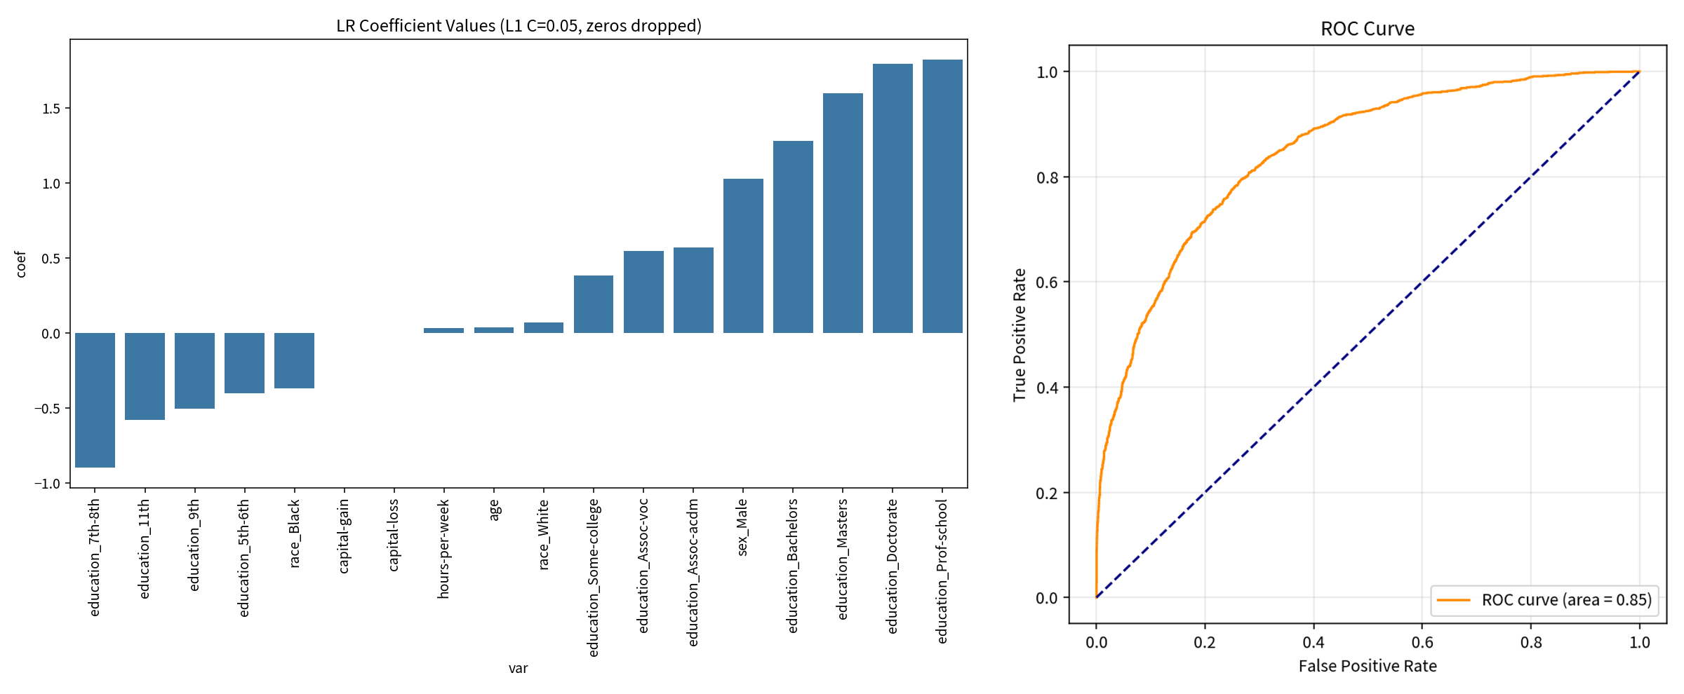
Left: L1 coefficients (zeros dropped). Right: ROC on the seed-1 test fold (AUC 0.85). A lower cutoff raises recall of high earners and raises false positives.

Key Takeaways
- Accuracy 83% is only 7 points above the 76% majority baseline. Lead with AUC and minority-class recall.
- Unscaled L1 is the lesson API and it converges, but scale if you want comparable coefficients or a fairer penalty.
- Education beyond high school dominates the sparse scorecard. Adding marital-status usually lifts AUC further.
- Sex and race are protected attributes. Their coefficients are associations in a 1994 snapshot, not causal wage effects, and may be illegal features in production.
- Good fit: binary independent rows, need for a readable scorecard, teaching imbalance + ROC. Not a fit: current wages, causal claims, regulated scoring that must drop protected attributes, or continuous income.

